Theory:
Over the past 30 years, there has been a significant advancement in thin film deposition technology. The demand for innovative goods and technologies in the electronics and optical industries was the main driver of this development. Without the creation of novel thin film deposition techniques, enhanced film properties, and superior film quality, the rapid advancement of solid-state electronic devices would not have been conceivable. Thin film deposition technology is still evolving quickly, which will eventually result in progressively more complicated and sophisticated electronic gadgets.
Semiconductors:
Semiconductor materials can be classified into two primary types based on their electrical conductivities: elemental semiconductors, which are made of a single element like silicon, and compound semiconductors, which are made of two or more elements like zinc oxide [1]. A semiconductor's electrical conductivity can be altered by adding impurities, changing the temperature and optical excitation intensity, or both. Since these materials' electrical properties may be adjusted to meet the requirements of a given application, they can be employed in a variety of settings. Solar cells, transistors, and diodes are some common semiconductor uses.
Energy Band Structure:
An isolated atom has a number of distinct energy levels, some of which are occupied by electrons. Valence electrons are found in energy levels that are either fully or partially filled. The electron energy levels are no longer distinct in solids because of the high amounts of atoms (about Avogadro's number 1023). A periodic potential results from the many atoms that are bound together. What is known as a nearly-free electron can be used to imitate the interaction between a single electron and other electrons. However, in solids where the atoms stay in close proximity to one another, the electrons and nuclei of nearby atoms act upon or disturb the electrons. Due to this influence, each discrete atomic state may divide into a number of closely spaced electron states in the solid, forming what is known as an electron energy band [2]. The outermost electron shells are the first to be disturbed as the atoms combine, hence they are where splitting starts. The magnitude of splitting depends on interatomic spacing.
The energy levels are separate within each band, yet the distance between adjacent states is incredibly small. The electron subshells closest to the nucleus may not form bands at the equilibrium spacing, as seen in Figure 2.1 (b). As seen in the image, gaps may also exist between adjacent bands; generally, the energies within these band gaps are unavailable for electron occupation. Figure 2.1 (a) illustrates the traditional method of displaying electron band structures in solids.
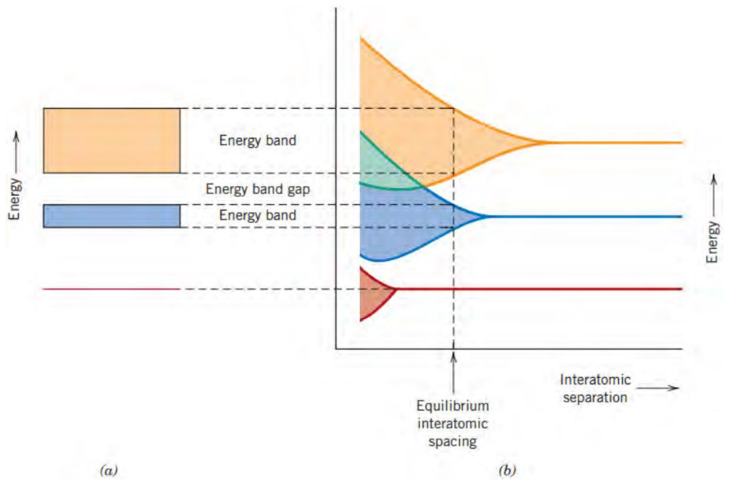

Figure 2.1: (a) The typical illustration of an equilibrium interatomic separation for the electron energy band structure in a solid substance. (b) Electron energy vs interatomic distance for a collection of atoms, showing the formation of the energy band structure at the equilibrium separation in (a). Reproduced from ref.[2].

The configuration of the outermost electron bands and how they are filled with electrons determine a solid's electrical characteristics, which are a result of this arrangement. In order to achieve electrical conductivity, electrons from the valence band (VB) must be stimulated into the conduction band, where they may travel in an electric field together with the holes in the valence band (VB). The size of this gap separates insulators from semiconductors and metals from semiconductors. At 0 K, four different kinds of band topologies are conceivable. One of the outermost bands in the first (Figure 2.2 a) is only partly filled with electrons. The Fermi energy, abbreviated Ef, is the energy associated with the maximum filled state at absolute zero. Some metals, especially those with a single s valence electron (like copper), are representative of this energy band structure. Each copper atom possesses one 4s electron, however the 4s band may hold up to 2N electrons in a solid made of N atoms. This means that just half of the available electron locations in the 4s band are occupied. There is an overlap between an empty band and a full band in the second band structure, which is also present in metals (Figure 2.2 b). This is the band structure of magnesium. All semiconductors are insulators at zero Kelvin. The major distinction between semiconductors and insulators is that semiconductors have lower band gaps than insulators, which permits electrons in the valence band to be driven to the conduction band when temperature is raised. Figure (2.2 c, d) illustrates that for insulators, the gap between the two bands is too wide for excitation under typical conditions.
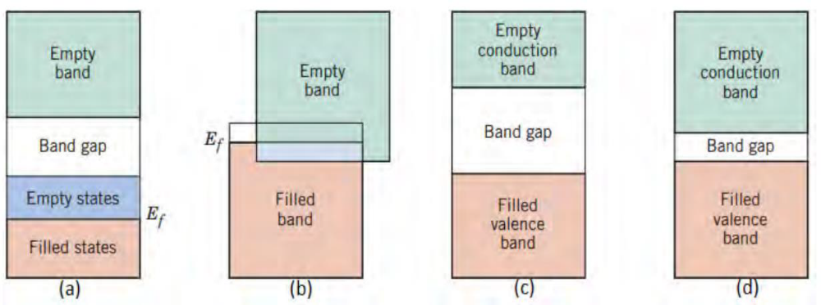

Figure 2.2: Different potential electron band configurations in materials at zero degrees Celsius. (a) Regarding metals like copper (b) Regarding metals like magnesium (c) Insulators and (d) Semiconductors. Reproduced from ref. [2].

Intrinsic and Extrinsic Semiconductors:
An intrinsic semiconductor is a pure semiconductor that has no impurities, dislocations, or other flaws. Since creating such a crystal is very impossible, it can only exist in theory. There are no electrons in CB at 0K because an intrinsic semiconductor lacks donors and acceptors. When covalent bonds are broken at higher temperatures, an electron-hole pair (EHP) is created when an electron is excited to CB and a hole (or missing electron) is left in VB. Therefore, in an intrinsic material, the number of electrons in CB (n) must be equal to the number of holes in VB (p), i.e. n = p = ni. (the quantity of intrinsic charge carriers, ni.)
Extrinsic semiconductors are those that have impurities or lattice flaws in them. By doping the material, the quantity of charge carriers can be customized for a particular application. Doping something is adding contaminants as acceptors or donors. Atoms with more valence electrons than the semiconductor material are known as donors.
The extra electrons can be used as conduction electrons by the semiconductor by being donated to it. On the other hand, acceptors are atoms that have fewer valence electrons and will so accept electrons from the crystal and thereby contribute holes. When donor doping is used, the amount of added impurities is typically high and the amount of electrons is so great that the amount of holes can be ignored. It's known as n-type doping.
When a p-type semiconductor is doped with a lot of acceptors, the electron count can be disregarded. As seen in Figure 2.3 (a), donors and acceptors have different energy levels that are referred to as donor- and acceptor levels, respectively. A donor level is referred to as a shallow donor if its energy is close to the conduction band, meaning that just a little amount of energy is required to excite the donor electrons to the conduction band. Deep donors are those whose donor level is closer to the band gap's center. Acceptor levels operate similarly, but in relation to the valence band.
In VB, electrons are quickly stimulated to these states, leaving holes in their wake. No semiconductor, regardless of how severely doped, has any electrons in the conduction band at absolute zero. For an n-type semiconductor, the donor atoms are ionized as the temperature rises, which causes the donor electrons to be stimulated to the conduction band (the ionization portion of Figure 2.3 b). All of the donor electrons are excited to CB as a result of further temperature rise, and the increase in the number of electrons excited to CB is zero (the extrinsic area of Figure 2.3 b).

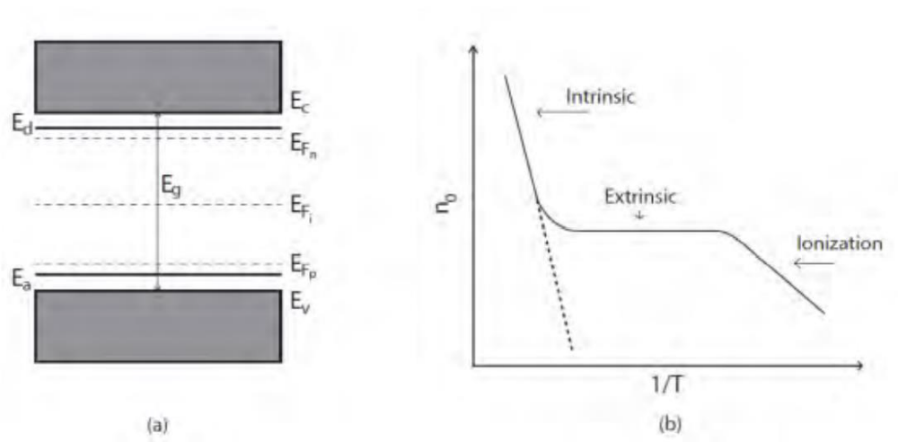

Figure 2.3: Band gap with the acceptor level, Ea, close to the valence band, and the donor level, Ed, close to the conduction band (a). Additionally, Figure (a) displays the Fermi levels for intrinsic semiconductors (EFi) and n- and p-type semiconductors (EFn and EFp), respectively. The electron concentration in CB is depicted as a function of temperature in Figure (b), along with the dominant mechanisms. The identical function for an intrinsic semiconductor is shown by the dashed line. reproduced using reference [2].

The intrinsic region of Figure (2.3 b) represents the point at which the temperature is high enough to excite electrons from the valence band to the conduction band. The same is true for p-type semiconductors, but at very low temperatures, electrons from the valence band are stimulated to the acceptor levels, leaving holes behind.

Charge carriers in semiconductors:
There are various factors that affect the number of electrons in the conduction band. The likelihood that an electron will occupy an energy state E at absolute zero temperature T is given by the Fermi Dirac distribution function;

f(E) = $\frac{1}{1+e^{(E-Ef)/KT}}$ … … … … … (2.1)

Nevertheless, the probability of locating an energy state with a hole in it is equal to the probability that an electron isn't present in it;

- f(E) =1 - $\frac{1}{1+e^{(E-Ef)/KT}}$ … … … … … (2.2)

The semiconductor's Fermi level is denoted by the symbol Ef, whereas T represents the temperature and k is the Boltzmann constant. At absolute zero, a semiconductor's Fermi level marks the boundary between its occupied and unoccupied states.
The Fermi level for intrinsic semiconductors is located in the center of the band gap, but for extrinsic semiconductors (n-type doping and p-type doping, respectively), the Fermi level is located closer to the conduction- and valence band.
Figure 2.4 displays the distribution function from equation (2.1).
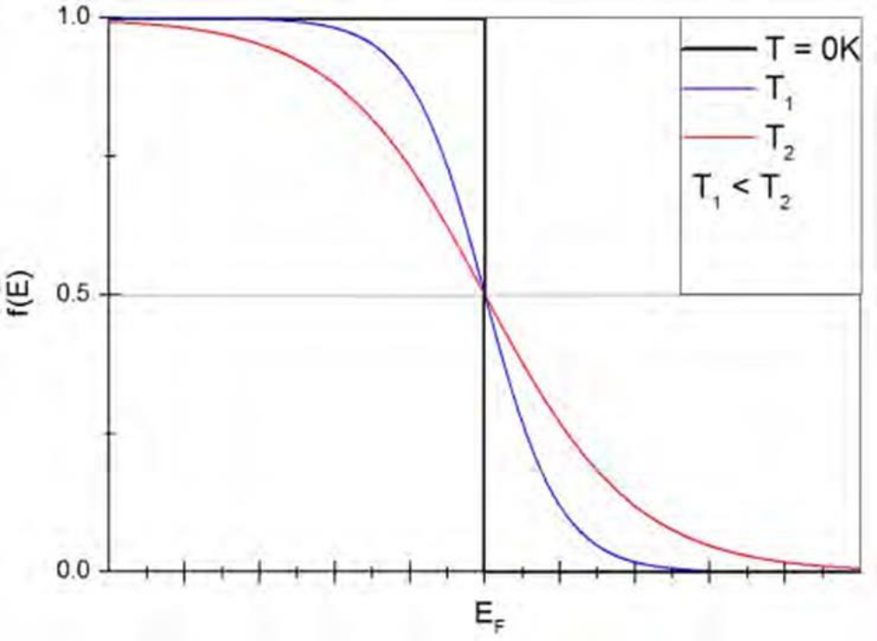

Fig 2.4: The distribution function of Fermi-Dirac. The distribution at 0 K is shown by the black line and represents a step-function at the Fermi energy, whereas the distributions are more smeared out for temperatures T1 and T2, which are higher than absolute zero. Reproduced from ref.[3]

Regardless of temperature, 50% of an energy state E = EF is occupied. The electron concentration in CB and the hole concentration in VB can be determined by looking at the likelihood that the energy state E = EC will be occupied. Equation (2.2) states that the probability of finding a hole becomes extremely small when the Fermi-Dirac distribution is close to one at low energies. Therefore, for energies below the top edge of VB, the hole concentration falls off quickly.

